**TOWN OF CARROLL FALL NEWSLETTER**

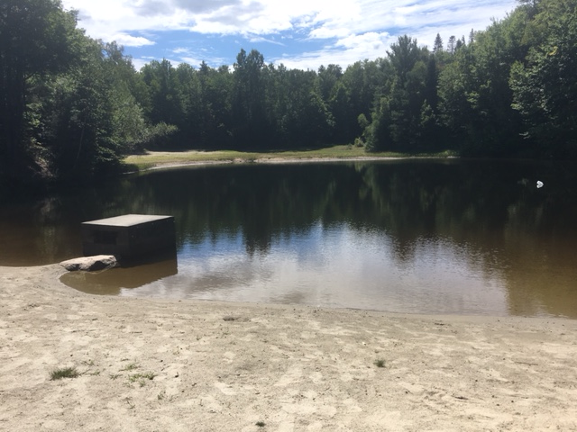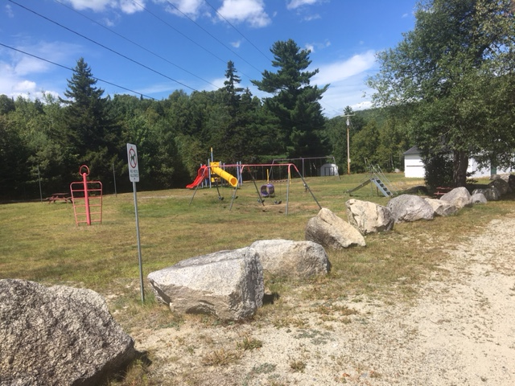

Well, that was quite a summer to say the least! Hope that you all had a great summer and made the best of your time. I was thinking of summer and in doing so I thought about the recreation area that we have in town. I was talking to a friend and asking if she remembers what year that opened the pond and beach area, and she said the thought it had always been there, but I believe it was made by the town for the enjoyment of the towns people at least 70 years ago. I went up there on a beautiful day and was rather surprised that there was nobody enjoying it, but I also noticed that the beach on the far side was growing grass where there never was any due to much use.

For many years there was a lot of activity here and there was also a Recreation Program every summer that was started by a group of mothers that wanted their children to have a place and activities in the summer. It blossomed from that to a committee that would hire counselors and get training for lifeguards. The program ran Monday thru Friday, there was a building put up to use for rainy days or inside activities. Ever since the Covid event there has not been a summer program for the kids I am sad to say. Maybe soon some parents would like to start one going again, as we seem to have more young children in the town again.

It was brought to the Select Boards attention that the float that is usually in the middle was not going to be able to be used again this summer, as it had damage and didn’t float anymore. The Board will make sure to put money in the budget so that those that do enjoy the pond have it available in 2026. Also, we are blessed enough to have bathroom/changing rooms as well but for some reason there a people that enjoy destroying things just because they can. This year some individual decided to put fireworks in the toilet and blow them up. This is not the first year that damage has been done, so the Board decided to lock them up, vs the taxpayers having to pay to repair these all the time. If someone comes to the town hall to sign up to use the recreation area for an event, we will make sure the bathrooms are available to use during those times.

**GETTING YOU THINKING AND AWARE BEFORE THE NEXT TOWN VOTE**

Last year you very generously voted to increase the Totally Disabled Veterans’ Tax Credit in accordance with RSA 72:35 from $2.000. to $4,000. And I would like to thank you all for doing that for those Veteran’s. So now during the 2025 legislative session, the New Hampshire General Court passed and Governor Ayotte that signed into law House Bill 99, amending RSA 72:35 effective on July 13, 2025. What this does is removes RSA 72:28-c that was an Optional Tax Credit for Combat Service for $750.00 for eligible veterans.

So with all that said, we will be putting another Warrant article in 2026 to increase RSA 72:35 to $4750.00. I am asking you to please consider voting yes to this warrant when you see it, as these Veteran’s deserve our support. Thank you.

**PLEASE BE AWARE**

**DUE TO NO RAIN THE WATER LEVEL HAS GONE DOWN IMMENSELY PLEASE DO NOT WATER LAWNS, AND TRY TO CONSERVE WATER.**



Feel free to contact any active member of the Auxiliary if you are interested in learning more about us. We invite you to participate!

Karen Moran, President 603-846-5935 or kjmoran1989@gmail.com

Carol Alvarez​ - Bobbi Amirault - Patti Cobb - Angela Loring​ - Janet Merner - Bonnie Moroney - Paula Murphy​ - Erin Oleson - Chris Pappas

Megan Basner - Steffanie Apostle - Judy Pappas - Lois Pessman​ - Susan Yellope

It’s been a busy summer for pancakes but we have one more to go!

held at the Fire Station from 7:30 – 10:30 AM,

Saturday October 11th Celebration of Foliage

**HELP US TO HAVE AN EVENING OF FUN AND GREAT FOOd**

**THE 1ST Carroll’s harvest dinner**

**A SMALL GROUP OF US ARE TRYING TO PUT TOGETHER A FUN EVENING AND WE NEED YOUR HELP!!!!!**

**WE HAVE PUT TOGETHER WHAT WE THINK IS A great MENU AND A TIME TO meet OTHER BUSINESSES OR GROUPs THAT MAY BE OUT THAT YOU DIDN’T KNOW ANYTHING ABOUT SUCH AS “WILD BLOOM BREWERY!” AND HOPEFULLY MANY MORE.**

**Please be sure to ask any new neighbors that you may have so we get to know them too!**

**OUR NEXT MEETING WILL BE THURSDAY SEPTEMBER 25TH AT 6PM AT THE COMMUNITY ROOM AT THE TOWN HALL. WE ARE LOOKING FOR GREAT IDEAS, PEOPLE TO HELP PUT THIS ALL TOGETHER, AND ALSO items and ideas FOR DONATIONS FOR THE RAFFLE TABLE, AND HARVESTED ITEMS FOR THE DINNER. If you’re not able to make the meeting, PLEASE FEEL FREE TO EMAIL BONNIE AND SHE WILL SHARE THEM WITH THE GROUP. (**[**pbandjmore@roadrunner.com**](mailto:pbandjmore@roadrunner.com)**).**

**\*\*\*\*\*\*\*\*\*\*\*\*\*\*\*\*\*\*\*\*\*\*\*\*\*\*\*\*\*\*\*\*\*\*\*\*\*\*\*\*\*\*\*\*\*\*\*\*\*\*\*\*\*\*\*\*\*\*\*\*\*\*\***

**COME ONE COME ALL**

**The town of Carroll’s harvest dinner**

**November 8, 2025 6 pm to 8 pm**

**Free will donation Raffle table ----------- BYOB**

**Come and meet the businesses AND OTHER HIDDEN TREASURES**

**Get out and see your neighbors or bring your new neighbors along!**

**We are HOPING TO USE AS MUCH AS POSSIBLE THINGS HARVESTED LOCALY**

**BISON OR Roast pork, with applesauce**

**Macaroni and cheese or ROASTED POTATOES**

**WINTER squash or maple carrots--Assorted desserts**

**We will also be offing “samples” of assorted wild GAME such as**

**bear sausage, wild turkey AND ????**

**If you always wanted to try them here is your chance**

**The proceeds to go towards a future**

**tennis – PICKELBALL court at the recreation area**

**Public Safety Building Solar PV Array System Nears Completion**

In March 2025, voters approved by a wide margin the installation of a solar PV (photovoltaic) array system on the Public Safety building. Powered by the sun, the system was designed to produce enough electricity to meet the building’s consumption on an annual basis.

With assistance from CENH (Clean Energy New Hampshire), the Carroll Energy Commission submitted a grant proposal in Aug. 2024 (which was approved in Nov. 2024) to cover much of the system’s cost. Additional funding will be sought from federal clean-energy tax credits and a state rebate.

On Jul. 23, Barrington Solar LLC and Mains Electric arranged delivery of 142 solar panels and corresponding racking systems, inverters, junction boxes, wiring, and other electrical components to route the energy produced by the solar PV panels through the inverters, which are connected to the building’s main electricity distribution system. Energy not consumed by the building will be exported to the Eversource Energy grid and credited to the Public Safety building’s electricity account for use in subsequent months.

Installation of the system was completed on Aug. 15, final inspection by town building inspector, David Scalley completed on Aug. 19, and final inspection and pre-commissioning testing completed by Mains Electric on Aug. 26. Final documents were submitted to Eversource Energy, which will arrange to replace the current meter with a bidirectional meter, ensuring proper credit for energy exported to the grid. The system is expected to go online by the end of September.

Before, during, and after installation, Will Cunningham, Deputy Chief of EMS with Twin Mountain Fire Dept. and Ambulance flew his drone to record stunning videos and capture still images of the building. Some of his videos and images will be included in reports to the NH DOE (Dept. of Energy) and CENH, documenting the project. One of Will’s videos was on display at the Aug. 30 Twin Mountain Fire Auxiliary Pancake Breakfast.

Anyone interested in learning more about the new solar PV array system is encouraged to contact the Carroll Energy Commission at [energycommission@townofcarroll.org](mailto:energycommission@townofcarroll.org). Watch for more information as well on the town’s website at [www.carrollnh.org](http://www.carrollnh.org).

Bill Vecchio, Carroll Energy Commission Chair

**TOWN OF CARROLL FOOD PANTRY**

Just a reminder that there is a food pantry in town for those that may be having a hard time for a while or if we can help you with some extra food. It is in the town hall and is open Monday through Thursday’s when the Offices are open. Feel free to stop in ask, and it you know someone that could use it please let them know to stop in as well.

SPEAKING OF BEING SAFE

It has been brought to our attention that we need to address the 911 numbers. In 2019 there was an update to the rules and regulations for the 911 numbers, we would not be cruel enough to post all 40 plus pages of this document, but instead address one issue that has been noticed recently. There are a lot of new buildings and new cottages with internet or phone that have been added or are in the process of being added and they each need their own 911 number. An example if your development has more than one driveway you need to name each of them exp. Bear Loop and Bear Road, than each building needs to have a 911 number of its own using exp: 3 Bear Loop, or 5 Bear Road. This is for your safety and anyone staying in this building. The Emergency departments have the 911 numbers to go by for the street address, but it they go into an unmarked area and must figure out where you are, you could be passed by the time they find you. So, lets plan ahead.

These things are not the responsibility of the Planning Board, they do not assign the 911 numbers, it is your responsibility as an owner to go see the Fire Chief Duncan or the Police Chief Bailey and get this set up.

Phone: 603-846-5545 FAX: 603-278-7944 email: twinmountainfirerescue@ townofcarroll.org

HONEY APPLE SALAD

In Memory of Gay “Olga” Jordan

1 cup Sour Cream ¼ tsp Cinnamon ¼ cup Raisins

1 T. Honey 4 cup coarsely chopped apples ½ cup sliced celery

1 cup seedless red grapes

In large bowl, stir together sour cream, cinnamon, and honey. Stir in all remaining ingredients until well coated. Cover, refrigerate at least 1 hour to chill.

**TWIN MOUNTAIN-BRETTON WOODS HISTORICAL SOCIETY**

Hello all!

Just a little memo to let everyone know what we have been up to so far this year. Our meetings are held on the first Wednesday of every month at 7:00 PM in the Town Hall Community Room. All meetings are open to all to just come and see what is going on and to bring your ideas.

For the past five years we have been discussing the fact that we need our own building – a Town of Carroll Historical Museum - to display all our historical pictures, items and clothing in the collection, presently in storage. We have contacted several funding sources but most notably the Northern Borders Regional Commission and the Tillotson Foundation to ask how we apply for grants for a museum. We have also been very active with raising funds. This year the society designed a new line of t-shirts and sweatshirts printed with the image of the Hermit of Crawford Notch, English Jack. We continue to add new images to our collection of vintage pictures of old hotels and inns, buildings and panoramas in Twin Mountain and Bretton Woods. The society had been selling these items along with others at all the Pancake Breakfasts and at the annual Vintage Fair in Bethlehem. We will also be at the Harvest Dinner on November 8th as well as the season’s last pancake breakfast on Saturday, October 11th. This past Labor Day weekend society members hosted a successful three-day yard sale at the former Jordan’s garage on Route 3 south. These fundraising efforts and planned grant applications will help getting the project underway. We have had a busy summer!

We are also looking to work with individuals and town committees of the town to study the possibility of see if we could combine the historical museum project with an outdoor pavilion for concerts or any number of events that could happen there. What an asset to the town that all would be! But we are really going to need all your help and support to see this through!

Lastly, we have been told a very large historical collection of a former Carroll resident will be donated to us next spring. The donor has only one request – not to have his collection in a lengthy storage but rather on display for all to enjoy and learn of the area’s rich history. More incentive to move on a home!

Thank you all and will have more to share in the next newsletter.