# **TOWN OF CARROLL NEWSLETTER**

**I would like to say thank you**

I, Bonnie Moroney, would like to take a minute to thank all of the wonderful people that have supported and voted me into the office of Selectperson, for what will be 12 years in March. I am so grateful to have been part of so many things such as the replacement of the bridge off Rte. 302, and the wonderful new buildings for the Town Offices, Police, Fire and Rescue, just to name a couple. I have decided that it is time for me to let somebody else step up and take the seat. I am telling you this now to give you time to think about running for this office or convincing somebody that you know would do a great job for the town and its caring people. It is important to have a name on the ballot in March, because if there isn’t, three things can happen. A write-in person with the most votes will be asked to take the seat. If they say no, the sitting Board has the right to appoint someone of their choosing in for one year or not put anybody in at all. I would also like to thank all the wonderful employees that I have had the honor of working with. I hope that the new Selectperson will recognize what a great group we have and be there for them and the town. Thank you.

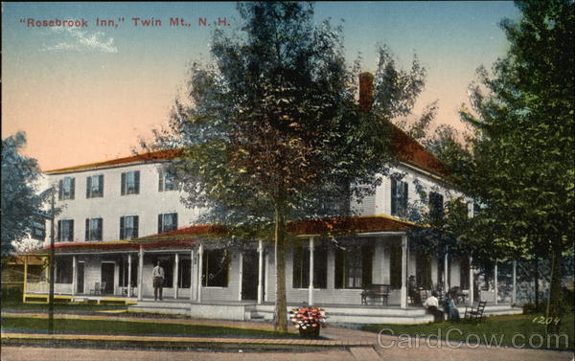

# **December 2020**

Well ready or not, after the year we’ve been having, we are heading for another New England winter!

The above picture is of the Rosebrook Inn and if you look really close you will recognize it as Foster’s Crossroads. The Rosebrook Inn was run from the late 1800’s until the 1960’s. It became Bob and Jenn’s Restaurant and in the 1970’s it was a lumber yard and plumbing supply company. In the late 70’s, it was purchased and became a convenience store with a welding shop in the barn next to the building. John and Donna Foster bought it in 1979 and it became Foster’s Crossroad Sports. They ran it over 30 years, selling it to RAJ LLC and Yatin and Nirali Patel, managing in 2016.

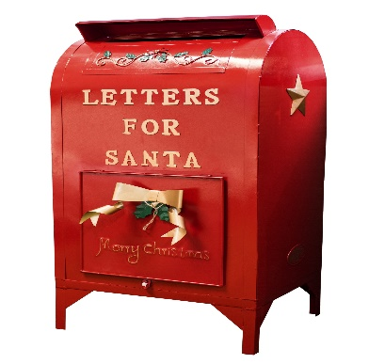

**LETTERS TO SANTA**

Back by popular demand at Yaya’s there is a special mailbox for **Letters to Santa**! So tell those little “Angels” that Santa is waiting to hear from them and is checking his naughty and nice list!

**Municipal Complex November 2020 Update**

Following the Twin Mountain Fire & Rescue Department and the Carroll Police Department move-ins into the new Public Safety building and the opening of the new Town Hall to the public in late June, final touches on both buildings continued into the fall.

The Twin Mountain Fire Auxiliary held four successful pancake breakfasts this year in the Fire Department apparatus bay allowing residents and visitors the opportunity to view portions of the new facility for the first time.

In keeping with state guidelines during the Coronavirus pandemic, both the State Primary on September 8th and the General Election on November 3rd were held in the Fire Department apparatus bay to provide adequate social distancing for voters and election officials.

On September 12th, months of planning and preparation by the Dedication Ceremony Committee, led by Chair **Mike Finn**, culminated in a well-attended formal dedication of the new buildings. Guest speakers included Governor **Chris Sununu**; **Chuck Henderson**, representing US Senator **Jeanne Shaheen**; **Brian Bresnahan**, representing US Representative **Ann Kuster**; Carroll Select Board Chair, **Rob Gauthier, Jr.**; Fire Chief **Jeremy Oleson**; Police Chief **Tadd Bailey**; and Select Board member, **Bonnie Moroney**.

Following the dedication ceremony, refreshments donated by the Omni Mount Washington Resort were served by the Twin Mountain Fire Auxiliary in the Public Safety building. Displays were set up in the Carroll Town Hall Community Room by the Carroll Garden Club, the Carroll 250th Anniversary Committee, the Twin Mountain–Bretton Woods Historical Society, and the Twin Mountain–Bretton Woods Chamber of Commerce. Drone video and still shots before, during and after the dedication ceremony, created by **Cait Cunningham** and **Will Cunningham** are available for viewing at <https://drive.google.com/drive/folders/10pN4hqPbKXqNpF9jefj03jGVcE0GOJvB?usp=sharing>.

While there are a few items yet to be completed, the New Town Hall and the new Public Safety building are fully operational.

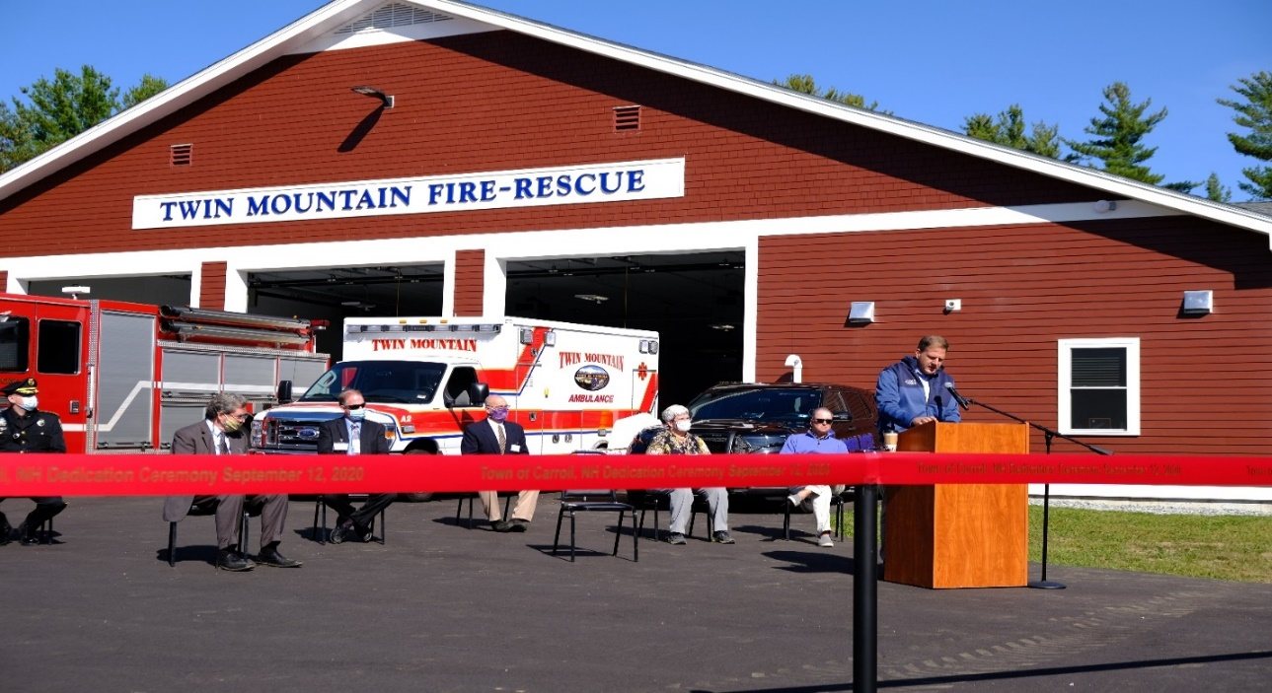

Governor Chris Sununu Addresses the Crowd at the Dedication Ceremony

Photo courtesy of Cait Cunningham

Thanks to all construction team members, town officials, volunteers, residents, businesses and guests for making this project so successful. May these facilities faithfully serve the community and those who work and visit them for many years to come.

Imre Szauter, former Building Committee Chair

**Easy Basundi Recipe | Caramel Basundhi Sweet**

So, because the picture is Foster’s Crossroads, I asked Yatin if there is a special recipe that they enjoyed during the holidays and this is what he was good enough to give me to put in. I have adjusted the recipe to oz. for those of us that don’t do metrics. Enjoy!

Easy Basundi Recipe to prepare rich & creamy dessert of thickened milk flavored with cardamom & saffron and garnished with nuts.

Prep Time 5 mins Cook Time 1 hr. Course: Dessert / Sweet / Festival Sweet Cuisine: Indian (North Indian)

**Ingredients**

* 2 quarts of regular milk
* 2 Tablespoons sugar
* ***For the Caramel Syrup:***
* ¼ cup cold water
* 1 cup sugar
* ***For Garnish:***
* 1 teaspoon Cardamom powder
* 10 pistachios
* 10 almonds blanched and peeled

**Instructions**

* Bring milk to a boil in a large, heavy bottomed wide vessel over medium heat.
* Once the milk starts boiling, reduce the heat to low. Allow the milk to simmer for 12-15 minutes, stirring in intervals of 2 to 3 minutes.
* Add 2 tablespoons of sugar at this point and keep stirring constantly.
* ***Caramel Syrup:*** Place the water and sugar into a heavy bottomed pan or saucepan and bring to a boil. Once the sugar reaches a dark amber color, remove it from the heat and place the saucepan into a bowl of ice water to prevent the sugar from continuing to cook. Remove and allow it to stand for 2 – 3 minutes until it thickens.
* Now add the caramel syrup to the boiling milk and stir.
* You will see that the milk starts to thicken slowly. This could take anywhere between 50 minutes to an hour.
* Turn off the heat once it reduces to less than 2/3 of the initial quantity.
* Allow to cool down slightly. Add cardamom powder and mix well.
* Garnish with the chopped nuts. Ladle into serving bowls and serve warm.
* You can even chill and serve it cold.

**THE TOWN HALL IS TEMPORARILY CLOSED**

Due to the increase in numbers of Covid – 19 cases in the North Country, it was decided by the Select Board to close the buildings to the public until the cases go down making it safer for the public and employees. As before, if you need any forms or applications, they can all be found on the Town of Carroll web page [www.townofcarroll.org](http://www.townofcarroll.org). Select Board meetings, Planning and Zoning meetings will continue on Zoom. Check the web page on how to participate or contact the office for the needed information. If you need to speak to one of the departments you can call:

Main Town Hall Number Auto Attendant 603-846-5494

Town Clerk 603-846-6208

Selectman’s Office 603-846-5754

Land Use (Planning & Zoning) 603-846-5775

Also, if you are in need of the Food Pantry, please feel free to call the Town Offices and the staff will try to help you. Thank you all and please be safe.

**POSITIONS AVAILABLE FOR March 2021**

Sign up dates are January 20th – 29th

Selectperson 3 year Treasurer 1 year

Library Trustees 3 year Town Clerk/Tax Collector 3 year

Planning Board 1 year Trustees of the Trust Fund 1 year Planning Board 3 year – 2 positions Trustees of the Trust Fund 3 year

Zoning Board 3 year – 2 positions

The reason for putting this list in the December Newsletter is so that you can be thinking of how you would like to do your civic duty and consider running for one of these openings. Maybe you know somebody that would do a great job and you could encourage them to run. Remember, most of these are not a daily job. The Planning and Zoning meets once a month. Please think about these and give them a try.

**Twin Mountain**

**Fire Department**

FIRETRK1

**Auxiliary**

On behalf of the entire Twin Mountain Fire Department Auxiliary, I thank you for helping to make the 2020 Pancake Breakfasts a success in the new station and as safe as possible. In this pandemic time, it was a challenge to which we, as a volunteer group, and you, as supporters, rose. I am deeply grateful for your thoughtfulness. Please continue to be vigilant. We look forward to 2021!

Karen Moran, President

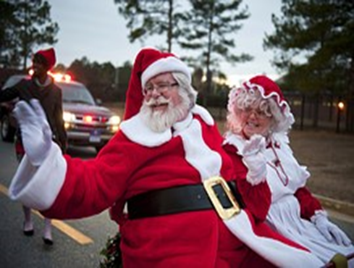

**SANTA AND MRS. CLAUS ARE COMING TO VISIT**

Santa and Mrs. Claus will be at the Town of Carroll Fire Department on Saturday December 19th from 2 to 4 PM

for pictures. The Elves are all very busy making the area very festive and safe for social distancing. Things are still the planning stages, but they are hoping to make it as much fun as possible for the children. Please stop by and enjoy the fun.

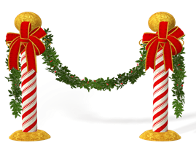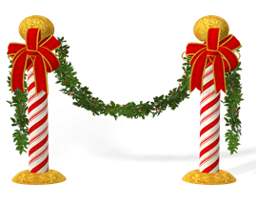

**TOWN OF CARROLL RECREATION DEPARTMENT**

The Recreation Department has been busy trying to get all the programs that the Recreation Department used to do up and going again. They of course have had many road blocks, as do all of us, with the Covid-19 issue this year. They wanted to update you on the plans they are hoping to move forward with in 2021. Plans are to open the summer recreation program again, but for the first year they would like to just have the Town of Carroll children. This will enable them to see how much interest there is so they have enough counselors.

There will not be a ski program for the end of 2020 and the first part of 2021, hopefully next winter season things will be better and they will be able to offer the program to the children again.

They did have a movie night during the summer that was quite successful. They would like to have it again and maybe frequently if it is well accepted. The Trunk-Or-Treat did not happen this year due to Covid-19 but hopes are to have it again for Halloween 2021. The group is currently working with YaYa’s to put together a safe meeting and pictures with Santa and Mrs. Claus for the children this year.

**TOWN OF CARROLL LIBRARY NEWS**  
New library hours are now Monday 3pm – 5pm, Tuesday 10am – 4pm, Wednesday 1pm – 5pm and Saturday 10am - 1pm.  We will go back to regular hours once Town Hall reopens.  
  
With the closure of Town Hall we now offering curbside pickup and drop off. Patrons can search and request items using the online catalog found at <https://www.librarycat.org/lib/Twinmountain>. Instructions on using the catalog for making requests for pickup can be sent by email or hard copies can be found in the yellow and black tubs located outside of the main doors to Town Hall during Library hours. Not all Library items are in the   
catalog and it's an ongoing project as we add in titles from our collection.  
  
Please renew items by email or phone. Please return all checked out items to the yellow and black tub labeled “Please place all Library returns to this tub” which will be outside the main doors of Town Hall during Library   
hours.  
  
The Library can be contacted by:  
Email at [twinmountainpl@roadrunner.com](mailto:twinmountainpl@roadrunner.com)  
Phone at 1-603-846-5818  
Facebook messenger. The Library's Facebook page is at   
<https://www.facebook.com/TwinMountainPublicLibrary> or can found using Facebook search.

**TOWN OF CARROLL GARDEN CLUB**

The Town of Carroll Garden Club finished the season with brilliant color displays in the town gardens. After a great summer, members of the Garden Club worked to put the gardens to bed this fall. Now the behind the scenes work begins. Club members are working on different avenues to create even more color and continue to beautify the public spaces.

There were additional donated plants and bushes which were not able to be planted around the Town Complex. With the dedication ceremony and timing of events, it was not feasible to plan for and plant all items. Those additional donations are being over wintered in some of the member’s gardens. We will now enjoy the winter and Holiday Season. Then back to work in the spring.

There are currently 13 members of the Town of Carroll Garden Club, representing the different sections of town. Many of us also belong to the Littleton Garden Club and have been enjoying socially distanced learning opportunities this year.

Please consider donating or joining us in the future.  This is a community supported garden and everyone's input is welcomed.  As always, any questions can be directed to Linda Finn at lindasstuff007@hotmail.com.

**TOWN OF CARROLL**

**250TH CELEBRATION**

Hello all!

The 250th Celebration has been slowed down as just about everything else with the pandemic. Hopefully 2021 will show good changes for us.

On September 12th, there was a Dedication for the new town offices and the Police & Fire Station. Mike Gooden and I were put in charge of the Twin Mountain-Bretton Woods Historical Society and the 250th Celebration Committee displays in the community room. Mike did a great job with the Historical display. He had about half of the walls filled starting with the churches, railroads, hotels, startup of the Historical and much, much more.

At the dedication, the 250th had displays from the 200th Anniversary celebration. We displayed an old dress from the 19th century that was worn by Phyllis Ricardi, the Bicentennial Cookbook, the Carroll History book, we ran slides from the 200th and many more items that were lent to us by the Historical Society.

The 250th Committee decided to make up 3 decals. (Examples on the back page.) June Rogier did the designs of two decals and Caroline Belise painted a beautiful picture of the old Town Offices that we used for the decal. We sold them at the dedication ceremony. You can buy them at the town office for $3.00 each. You will find pictures of the decals after this letter. The money goes to the celebration events or to help with other ways to raise money. Not knowing what or when we can have events for fundraising is hampering us. There will be a celebration, we just don’t know how or when.

So again, we are taking time off because of Covid. You can buy the decals thru the town offices or thru the 250th Celebration email.

Thank you! Happy Holidays to all!

The 250th Celebration Committee

Carroll250th@gmail.com



  
  
  